|  |  |
| --- | --- |
| Name: | Prerna Sunil Jadhav |
| Sap  Id: | 60004220127 |
| Class: | S. Y. B.Tech (Computer Engineering) |
| Course: | Computer Networks (DJ12CEL405) |
| Date of Performance: |  |
| Date of Submission: |  |
| Experiment  No.: | 08 |
| Aim: | RIP configuration using packet tracer |

**AIM: RIP CONFIGURATION USING PACKET TRACER**

**THEORY:**

* Routing Information Protocol (RIP) is a dynamic routing protocol that uses hop count as a routing metric to find the best path between the source and the destination network.
* It is a distance-vector routing protocol that has an AD value of 120 and works on the Network
* layer of the OSI model.
* RIP uses port number 520.
* Hop count is the number of routers occurring in between the source and destination network. The path with the lowest hop count is considered as the best route to reach a network and therefore placed in the routing table.
* RIP prevents routing loops by limiting the number of hops allowed in a path from source and destination.
* The maximum hop count allowed for RIP is 15 and a hop count of 16 is considered as network unreachable.
* Features of RIP
  + Updates of the network are exchanged periodically.
  + Updates (routing information) are always broadcast.
  + Full routing tables are sent in updates.
  + Routers always trust routing information received from neighbour routers. This is also known as Routing on rumors.
* RIP versions:
  + There are three versions of routing information protocol – RIP Version1, RIP Version2, and RIPng.

The Network:

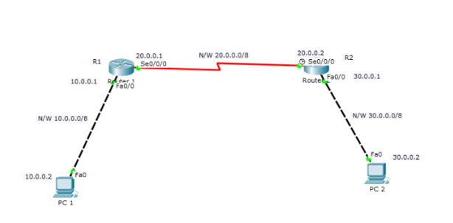

Configuring Router 1:

R1(config)#int fa0/0

R1(config-if)#ip address 10.0.0.1 255.0.0.0

R1(config-if)#int serial 0/0/0

R1(config-if)#ip add 20.0.0.1 255.0.0.0

R1(config-if)#no shut

Configuring Router 2:

R2(config)#

R2(config)#int fa0/0

R2(config-if)#ip add 30.0.0.1 255.0.0.0

R2(config-if)#no shut

R2(config-if)#

R2(config-if)#int serial 0/0/0

R2(config-if)#ip add 20.0.0.2 255.0.0.0

R2(config-if)#no shut

